Runner Plans

ANY TIME YOU ARE THE BATTER
- If I hit a single, I sprint past the bag and use my ears to hear base coach
- If I hit a possible double, I round the bag, lead off and find the ball while listening to base coach
- If I hit a monster, I’m going 2nd base or more so I sprint rounding 1st base and keep my focus on 2nd base using a quick glance to see 3rd base coach.
ANY TIME YOU ARE A RUNNER ON BASE
- Most important, focus on being a fast runner and commit
- Watch the back foot of pitcher to tell if he’s going try and pick you off
- Always plan on going to the next base
- Stop on pops, pop flies require you to tag up

NO RUNNERs

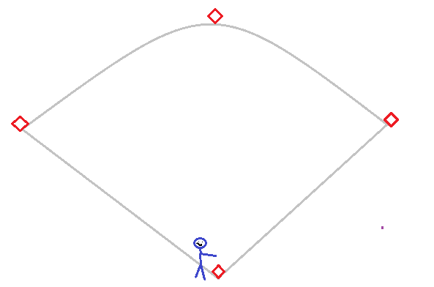
- Follow the rules in “ANY TIME YOU ARE THE BATTER”
RUNNERS ON: 1B
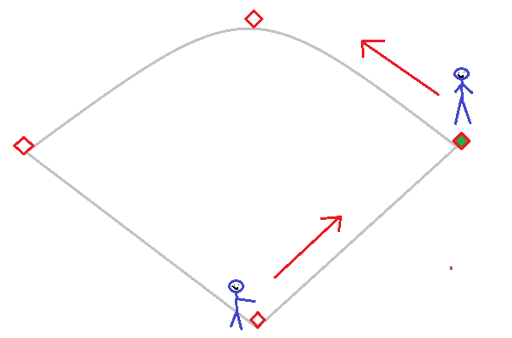
YOU ARE: THE BATTER
- Follow the rules in “ANY TIME YOU ARE THE BATTER”
YOU ARE: ON 1st BASE
- Pitcher pass ball, steal 2nd base. If you’re fast steal as soon as pitching commits to pitch.
- Ball hit on ground, run as hard as you can and only look at base in front of you.
RUNNERS ON: 1B, 2B
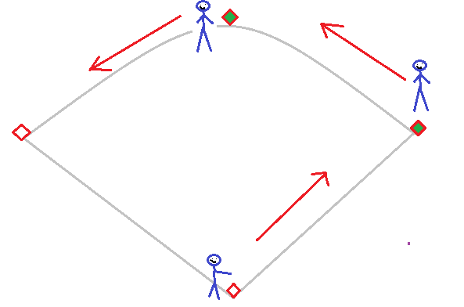
YOU ARE: THE BATTER
- Follow the rules in “ANY TIME YOU ARE THE BATTER”
YOU ARE: ON 1st BASE
- Pitcher pass ball, check to see what runner on second is doing, if he goes you go.
- Ball hit on ground, run as hard as you can and only look at base in front of you
- Ball in the outfield, ensure they don’t catch it, if they don’t plan on going to 3rd base.
YOU ARE: ON 2nd BASE
- Pitcher pass ball, steal 3rd base.
- Ball hit on ground, run as hard as you can and only look at base in front of you.
- Ball in the outfield, ensure they don’t catch it, if they don’t plan on going home base.
RUNNERS ON: 1B, 2B, 3B
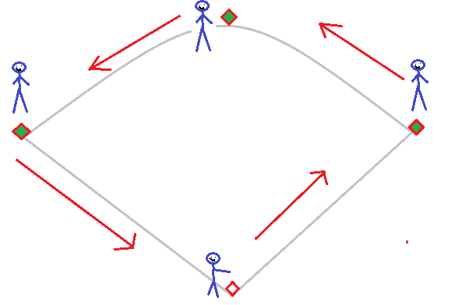
YOU ARE: THE BATTER
- Follow the rules in “ANY TIME YOU ARE THE BATTER”
YOU ARE: ON 1st BASE
- Pitcher pass ball, check to see what runner on 2nd is doing, if he goes you go.
- Ball hit on ground, run as hard as you can and only look at base in front of you
- Ball in the outfield, ensure they don’t catch it, if they don’t plan on going to 3rd base.
YOU ARE: ON 2nd BASE
- Pitcher pass ball, check to see what runner on 2nd is doing, if he goes you go.
- Ball hit on ground, run as hard as you can and only look at base in front of you.
- Ball in the outfield, ensure they don’t catch it, if they don’t plan on going home base.
YOU ARE: ON 3rd BASE
- Pitcher pass ball, check to see what runner on 2nd is doing, if he goes you go.
- Ball hit on ground, run as hard as you can and only look at base in front of you.
- Ball in the outfield, ensure they don’t catch it, if they don’t plan on going home base.

RUNNERS ON: 2B
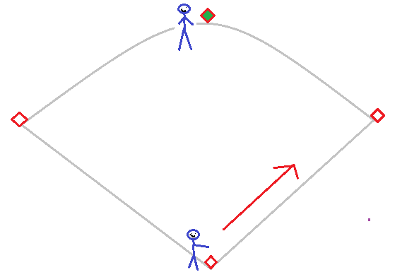
YOU ARE: THE BATTER
- Follow the rules in “ANY TIME YOU ARE THE BATTER”
YOU ARE: ON 2nd BASE
- Pitcher pass ball, run as hard as you can to 3rd base.
- Ball hit on ground and it’s an infield to right side sprint to 3rd base. If it’s an outfield hit, not caught pop fly, run hard home
- Ball in the outfield, run home hard.
RUNNERS ON: 2B, 3B
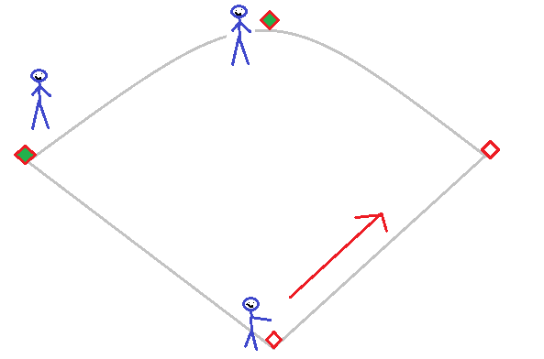
YOU ARE: THE BATTER
- Follow the rules in “ANY TIME YOU ARE THE BATTER”
YOU ARE: ON 2nd BASE
- Pitcher pass ball, depending on rules you might not be able to steal because the runner on 3rd has to stay.
- Ball hit on ground and it’s an infield to right side sprint to 3rd base. If it’s an outfield hit, not caught pop fly, run hard home
- Ball in the outfield, ensure they don’t catch it, if they don’t run hard home.
YOU ARE: ON 3rd BASE
- Pitcher pass ball, check to see what runner on second is doing, if he goes you go.
- Ball hit on ground, run as hard as you can, not looking at ball.
- Ball in the outfield, ensure they don’t catch it, run hard home.
- Ball hit in outfield is caught, tag up and run home.
RUNNERS ON: 1B, 3B
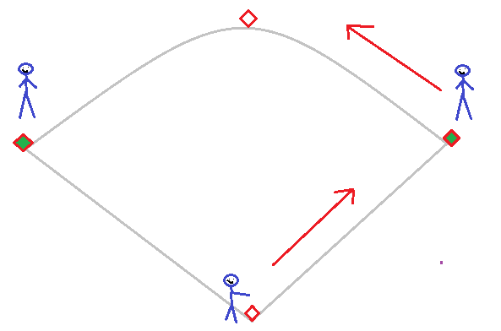
YOU ARE: THE BATTER
- Follow the rules in “ANY TIME YOU ARE THE BATTER”
YOU ARE: ON 1st BASE
- Steal 2nd base as soon as the pitcher is committed to pitch.
- Ball hit on ground, run as hard as you can 2nd base and do not look at ball.
YOU ARE: ON 3rd BASE
- Pitcher pass ball, if the ball is far from catcher run home.
- Ball hit on ground, run as hard as you can, not looking at ball.
- Ball in the outfield, ensure they don’t catch it, run hard home.
- Ball hit in outfield is caught, tag up and run home.

RUNNERS ON: 3B
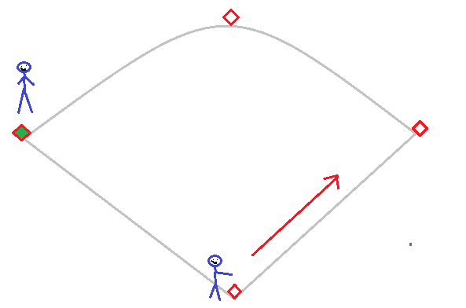
YOU ARE: THE BATTER
- Follow the rules in “ANY TIME YOU ARE THE BATTER”
YOU ARE: ON 3rd BASE
- Pitcher pass ball, if the ball is far from catcher run home.
- Ball hit on ground, run as hard as you can, not looking at ball.
- Ball in the outfield, ensure they don’t catch it, run hard home.
- Ball hit in outfield is caught, tag up and run home.

